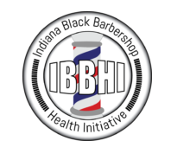

1BBHI 10th Anniversary
2022 Celebration

SPONSORSHIP PROSPECTUS

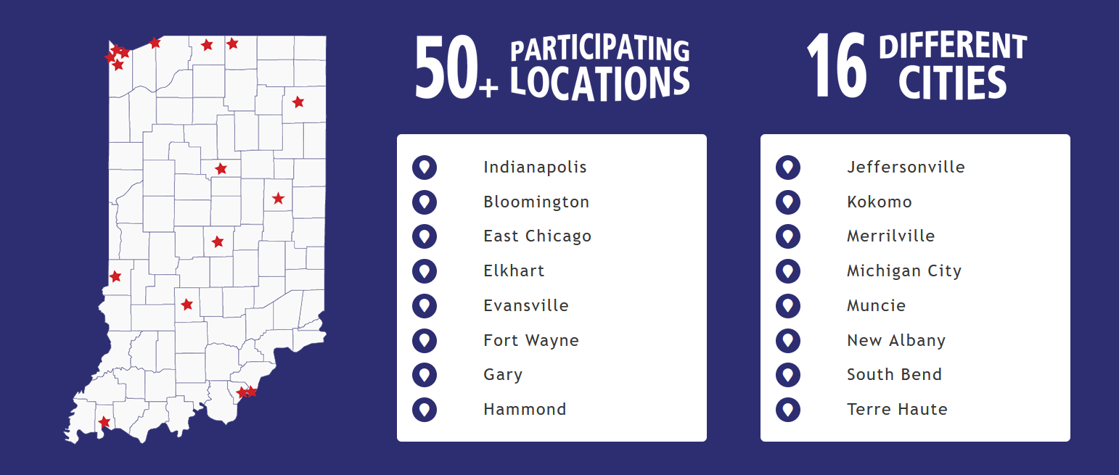

EXECUTIVE LETTER

February 1st, 2022

Sponsoring Organizations
Address
Address
Dear Sponsor Decision Maker,
Thank you for your continued leadership in advancing community health!
We invite you to sponsor the Indiana Black Barbershop Health Initiative, a Statewide community outreach, vital signs screening and health education event led by community leaders, health champions, and sponsor organizations across 17 communities!

This year’s theme is our 10th anniversary and the National Minority Health Month theme of “Give a boost to our communities”.

Our mission is to bring focus and support to African-American men’s health across the State of Indiana, educate men on their self-advocacy of their health, and share information to promote healthy behaviors.
Please review the sponsorship prospectus and connect with Mr. James Garrett, Jr., Executive Director of the Indiana Commission on the Social Status of Black Males with any questions.
Sponsorship commitments must be received by March 30th, 2022 with payment due by April 30th, 2022.
We look forward to your sponsorship!

Sincerely,
_[Insert e-signature]______________________
James Garrett, Jr.
Executive Director
Indiana Commission on the Social Status of Black Males
100 North Senate Avenue, Room N300
Indianapolis, IN 46204
Office phone: 317.233.1744
Work cell: 317.670.7125
TTY: 1-800-743-3333
Fax: 317.232.6580
Email: jgarrett@icssbm.in.gov
Web: www.in.gov/icssbm
SPONSORSHIP FORM – PAGE 1 of 2
To be completed by Sponsoring Organization
Organization Name: ______________________________________________________
Contact Person: ______________________________________________________

Contact Person Title: ______________________________________________________
Best Reach Phone: ______________________________________________________
E-mail: ______________________________________________________
Street Address: ______________________________________________________

City, State, Zip Code: ______________________________________________________
Organization Website: ______________________________________________________

Is the organization a 501(c)3 non-profit? Circle: YES NO

Brief description of your organization. (Please use maximum of 250 words. Description will be used for marketing.)

How do you support African-American men’s health today? (Please use maximum of 250 words. Description will be used for marketing.)

SPONSORSHIP SELECTION
Please select requested sponsorship tier and total sponsorship amount in the space below:
- Annual Barbershop Health Initiative Statewide April Event Sponsor (1) – $20,000
- Statewide Healthy Behaviors Education Series May through September Sponsor (1) – $20,000
- Community Gold Sponsor (multiple) – $5,000
- Community Silver Sponsor (multiple) – $3,000
- Community Bronze Sponsor (multiple) – $1,500
- Community Friends Sponsor (multiple) – $250

Total Sponsorship Amount: ____________________________ (Sponsorships are not tax deductible.)

SPONSORSHIP FORM – PAGE 2 of 2
This document is a legally binding sponsorship agreement between the
[Insert Sponsoring Organization Name]
and the National Wellness Institute, the fiduciary to the Commission on the Social Status of Black Males for the 2022 Indiana Black Barbershop Health Initiative.

Signature of Authorized Representative: ___________________________________
Printed Name of Authorized Representative: ______________________________________
Date: _________________________________

PAYMENT INSTRUCTIONS
Payment made by credit card:
For Sponsors choosing to pay by credit card, please access online payment via:
[Insert Website Link]

Payment made by physical checks:
For Sponsors choosing to pay by physical check, please mail your check made out to:
National Wellness Institute
ATTN: IBBHI/Chuck Gillespie
PO Box 827
Stevens Point, WI 54481
Please state on memo line of check: 2022 IBBHI Sponsorship
Please email your completed sponsorship form to:
Mr. James Garrett, Jr., Executive Director of the Indiana Commission on the Social Status of Black Males at jgarrett@icssbm.in.gov
Invoice requests may be directed to:
Mr. Chuck Gillespie, CEO at National Wellness Institute at chuck@nationalwellness.org

Sponsorship Levels & Benefits
 | 10 Year Anniversary  IBBHI Title Sponsor  STATEWIDE  April  (1)  $20K | Healthy Education Series  STATEWIDE  May-Sept  (1)  $20K | Community Sponsors  April Event  Multiple Sponsors per Community  Community Gold - $5,000  Community Silver - $3,000  Community Bronze - $1,500  Community Friends - $250
Shop-based Promotional Package | April Event Shop Posters – Premium Placement | Monthly Educational Series Shop Posters | April Event Shop Posters – Placement by Sponsor Tier
Co-Branded Items | 10th Anniversary Celebration T-Shirt  Title Placement on back of shirt |  | T-Shirt Recognition  GOLD – logo displayed in middle of shirt  SILVER – logo displayed in lower middle of shirt  BRONZE – name displayed in large font in alphabetical listing  FRIENDS – name displayed in standard font in alphabetical listing
Website | Sponsor Name  Sponsor Logo  Sponsor Blurb  Sponsor Redirect to website | Sponsor Name  Sponsor Logo  Sponsor Blurb  Sponsor Redirect to website | GOLD – Sponsor Name, Sponsor Logo large sized placement  SILVER – Sponsor Name, Sponsor Logo medium sized placement  BRONZE – name displayed in large font in alphabetical listing  FRIENDS – name displayed in standard font in alphabetical listing
Social Media  # of mentions | 2 Sponsor spotlight posts per during April; 4 weeks at 8 total posts. | 2 Sponsor spotlight posts each month of educational series; 5 months at 10 posts total | GOLD – 4 sponsor spotlight during April event  SILVER – 2 sponsor spotlight during April event  BRONZE – 1 sponsor spotlight during April event  FRIENDS – 1 group sponsor post during April event
Special Activity | Co-Host of 10th Anniversary Virtual Celebration in May | Sponsor logo placed on fruit baskets & veggie platter trays provided weekly for participating barbershops on Saturdays. | 10th Anniversary Virtual Celebration Program  GOLD – Sponsor Name, Sponsor Logo large sized placement  SILVER – Sponsor Name, Sponsor Logo medium sized placement  BRONZE – name displayed in large font in alphabetical listing  FRIENDS – name displayed in standard font in alphabetical listing
Educational Brochures | - CDC Vaccination information (CDC logo only)  - IDOH brochures printed with IBBHI logo & 10 Year Anniversary Sponsor + Community Sponsor logos

